**MINI-PROJECT REPORT**

Bus Reservation System



# NAME: - Kommalapati Sowmya

**TABLE OF CONTENTS**

|  |  |
| --- | --- |
| **SERIAL No.** | **CONTENT** |
| 1 | Introduction |
| 2 | Objective |
| 3 | Features |
| 4 | 4 W’s 1H |
| 5 | SWOT Analysis |
| 6 | Requirements |
| 7 | Architecture |
| 8 | Use case diagram |
| 9 | Expected results/Outcomes |

# Introduction:

“Online Bus Reservation System” is windows based application that works within centralized network.The software program “Online Bus Reservation System” provides bus transportation system, a facility to reserved seats, cancellation of seats and different type of enquiry which need on instant and quick reservation.OBTRS is built for manage and computerized the traditional database, ticket booking and tracking bus and travel made easy. It maintains all data of users, bus details, reservation details, booking details, customer details.

# Objective:

The main objective of the project entire to automate the ticket booking process of day to day activities of system library like:

1. Ticket activities
2. Creation of a Customer ID.
3. Assign a bus ticket according to customer’s demand.
4. Advance booking
5. Bus ticket Cancellation
6. Feedbacks

# Benefits:

1. Online booking system save your staff time.
2. Removing the bottleneck of phone booking system.
3. Greater sales and marketing synergy.
4. A modern approach to booking.
5. Increased revenue thanks to upselling.
6. Can come at a cost.
7. Requires internet access.

# Features:

1. System setting management.

2.Online ticket booking.

3.Real Time booking system.

4.Booking cancel Request.

5.Easy to sign up/sign in.

6.Trip Management.

7.Profile Management.

8.Agent Management.

9**.**Admin Dashboard.

* WHO:People can book bus tickets or seats from anywhere using an online bus reservation system. People who are busy with their current employment benefit the most from an online booking system.

WHAT:The Online Bus Ticket Reservation System is a web based application that allows visitors check bus ticket availability, buy bus ticket and pay the bus ticket online. This system is established for all the home/office users after gaining access from the administrator.

* WHERE:Used in all over the world.
* WHEN:Customers can use a bus ticket reservation system to reserve tickets online. The Bus Reservation System is a user-friendly online bus booking system that automates online ticket purchases.
* HOW:Social Media Login.
* Online Payment Modes.
* GPS Integration.
* Enable Real-Time Seat Availability.
* Include a Chat Window.
* Offer Complete Authentication.
* Plan the Booking Management Module.
* Advanced Features for Bus Ticket Booking App.

# SWOT Analysis

# Strengths:

1.Advantages of the organization.

2.Activities of the company better than competitors.

3.Unique resources and low cost resources company have.

4.Activities and resources market sees as the company’s strength.

5.Unique selling proposition of the company.

**WEAKNESS:**

1.Improvement that could be done.

2.Activities that can be avoided for Online Bus Reservation System.

3.Activities that can be determined as your weakness in the market.

4.Factors that can reduce the sales.

5.Competitor’s activities that can be seen as your weakness.

**OPPORTUNITIES:**

1.Good opportunities that can be spotted.

2.Opportunities for Online Bus Reservation System can be obtained form things such as;

3.Change in technology and market strategies.

4.Government policy changes that is related to the company’s field.

5.Changes in social pattern and lifestyles.

6.Local events.

**THREATS:**

1.Company facing obstacles.

2.Activities of competitors.

3.Product and services quality standards.

4.Threat from change in technologies.

5.Financial/cash flow problems.

6.Weakness that threaten and that business.

# REQUIREMENTS



**High Level Requirements:-**



| **ID** | **DESCRIPTION** | **Category** | **STATUS** |
| --- | --- | --- | --- |
| HR01 | user can be able to access bus list | Technical | IMPLEMENTED |
| HR02 | user cane be able to access number of seats | Technical | IMPLEMENTED |
| HRO3 | user can be able to see the list of passengers name | Technical | IMPLEMENTED |
| HRO4 | user cane be able to choose the bus seats | Technical | IMPLEMENTED |
| HRO5 | user can be able to show passengers ticket details | Technical | IMPLEMENTED |
| HR06 | user can be able to show confirming the available seats | Technical | IMPLEMENTED |
| HR07 | user can be able to cancelling the tickets | Technical | IMPLEMENTED |
| HR08 | User can be able to access the login page | Technical | IMPLEMENTED |

Low Level Requirements:-



| **ID** | **DESCRIPTION** | **HLR ID** | **STATUS(IMPLEMENTED/IN PROGRESS)** |
| --- | --- | --- | --- |
| LR01 | user must choose the option for list of available bus in the reservation system | HR01 | IMPLEMENTED |
| LR02 | same operation for accessing number of seats in the reservation system | HR02 | IMPLEMENTED |
| LR03 | same operation for to view the list of passengers name in the reservation system | HR03 | IMPLEMENTED |
| LR04 | same operation for choosing number of avaliable seats in the reservation system | HR04 | IMPLEMENTED |
| LR05 | same operation for to view the passengers ticket details in the reservation system | HR05 | IMPLEMENTED |
| LRO6 | same operation for confirmed the available seats | HR06 | IMPLEMENTED |
| LR07 | same operation for cancelling the booked ticket by user | HRO7 | IMPLEMENTED |
| LR08 | user can view the welcoming page to accessing all operation easily | HR08 | IMPLEMENTED |

**Architecture:**

**ER DIAGRAM:-**

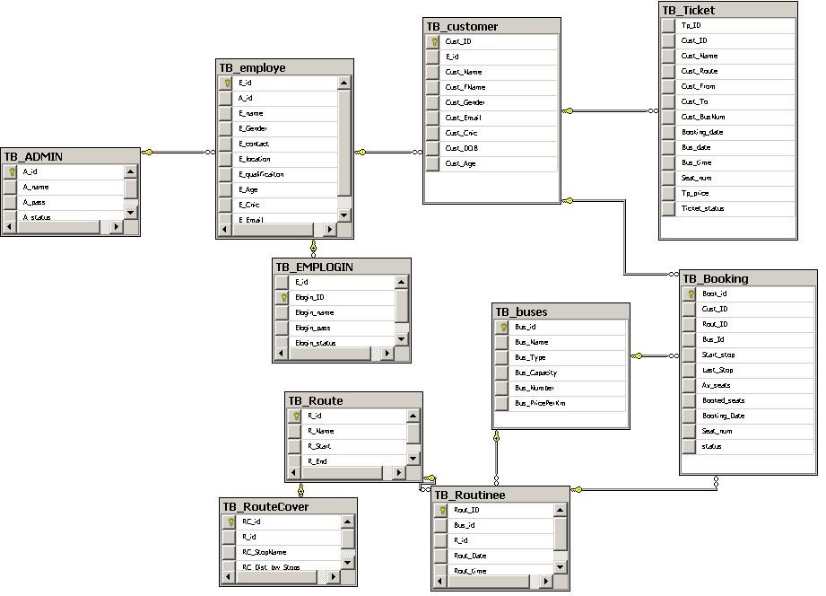

**FLOW DIAGRAM:-**

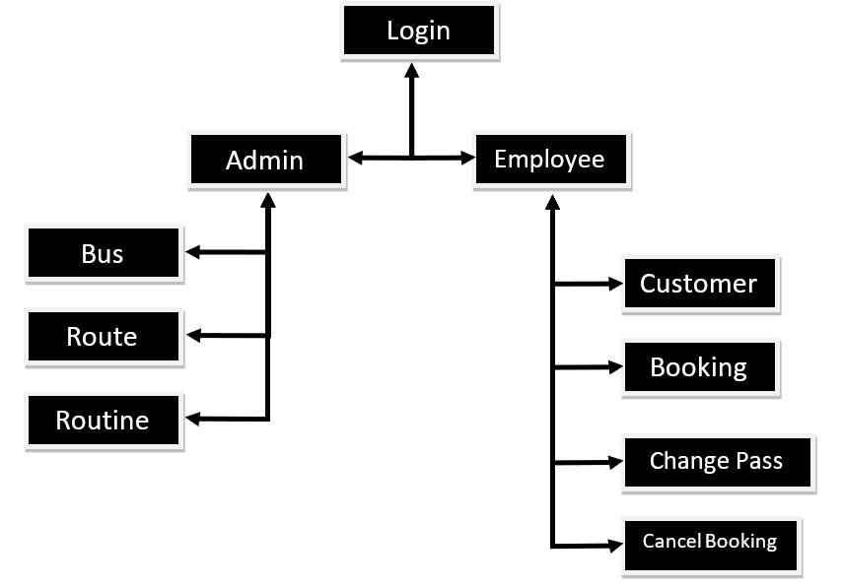

**USE CASE DIAGRAM:-**

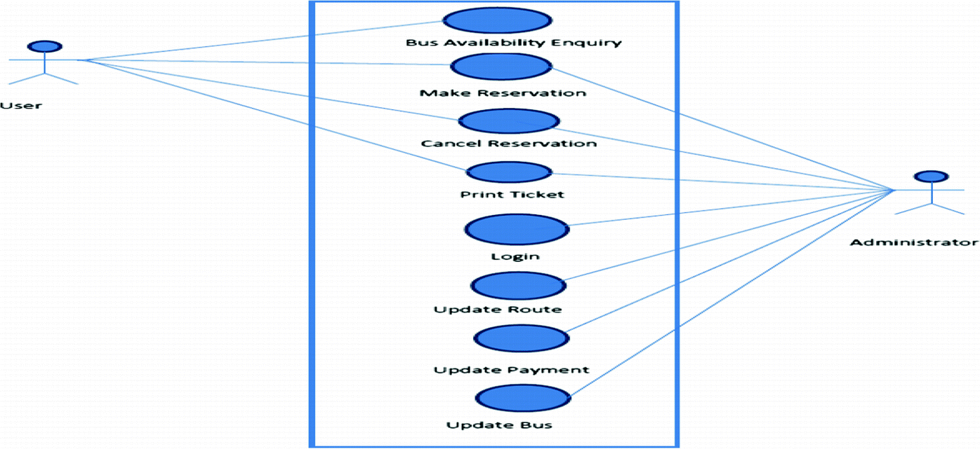

**SEQUENTIAL DIAGRAM:-**

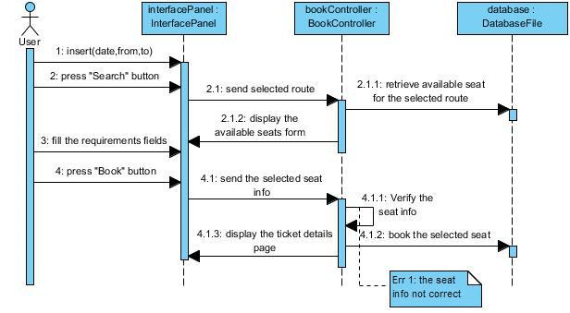

**OUTPUT IMAGES:-**

